SHOPNEST STORE ANALYSIS REPORT

SALES & PERFORMANCE DASHBOARD REPORT

**LIFE KUMAR DIGAL**

**lifedigal15@gmail.com**

1.Top 10 Categories by Total Price

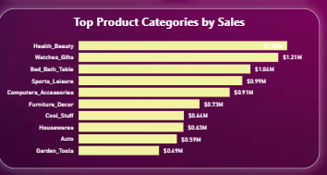

Key insights and findings

* Revenue is **heavily concentrated in the top 3 categories**, which together contribute a large share of total sales.
* Sales drop noticeably after the top 3, indicating a performance gap.
* Bottom categories may need targeted marketing, product improvement, or reconsideration in strategy to increase contribution.
* The close performance of some mid-tier categories suggests potential for growth with focused efforts.

2.Delayed Orders Analysis

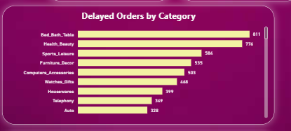

Key insights and findings

* The **top two categories** (Bed, Bath & Table, Health & Beauty) account for a significant portion of all delays, suggesting potential operational or supply chain bottlenecks in these segments.
* Categories with high sales (like Health & Beauty) also have high delays, indicating possible fulfillment capacity issues.
* Lower-ranked categories in sales (e.g., Telephony, Auto) have fewer delays, but this may be due to lower order volumes rather than better performance.
* Addressing delays in the top categories could have the largest impact on overall customer satisfaction and operational efficiency.

3.Monthly Comparison of Delayed and On-Time Orders

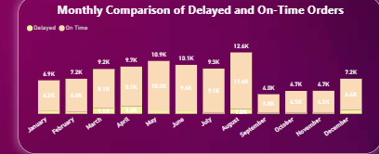

Key insights and findings

* The business struggles with timely deliveries in the **first eight months**, especially in peak months like **August**, indicating possible capacity or supply chain constraints during high demand.
* **September and October** show significant operational improvement, with a shift toward more on-time deliveries.
* Sustaining the efficiency seen in October could greatly improve overall performance and customer satisfaction.

4.Payment Method Analysis

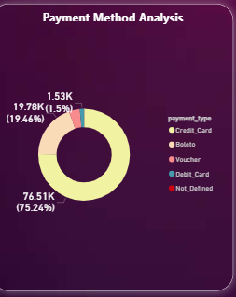

Key insights and findings

* The overwhelming reliance on **Credit Cards** suggests customer preference for this method, but also indicates high dependency on one payment channel, which could be risky if processing issues occur.
* **Boleto** still holds a notable share, reflecting its importance for customers who prefer offline or alternative payment methods.
* Minimal adoption of **Voucher** and **Debit Card** presents an opportunity for promotions or incentives to diversify payment method usage.

5.Product Rating Analysis

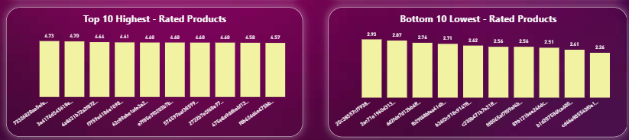

Key insights and findings

* High ratings likely reflect good product quality, accurate descriptions, and strong fulfillment for those items. These products could be promoted as “customer favorites” to boost sales.
* Low ratings signal issues that may include poor quality, misleading descriptions, or delivery/service problems. These products need urgent review to address root causes.
* Consistently improving low-rated products could significantly raise overall customer satisfaction and brand reputation.

6.State-wise Sales Analysis

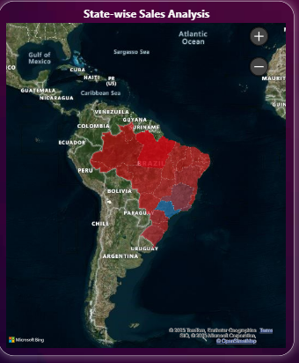

Key insights and findings

* The brand has successfully penetrated diverse geographic markets within Brazil, suggesting strong distribution coverage.
* State-level differences in sales could be influenced by population density, economic activity, and logistics efficiency.
* Identifying top-performing states can help replicate successful strategies elsewhere, while low-performing areas may need targeted marketing or improved delivery networks.

7.Seasonal Sales Pattens

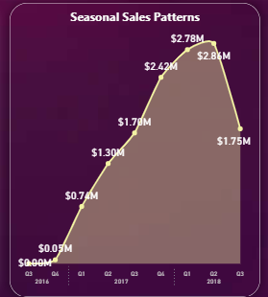

Key insights and findings

* The significant sales rise between 2016 and mid-2018 suggests successful product demand, marketing, and possibly seasonal boosts.
* The drop after Q2 2018 could indicate seasonal slowdown, market saturation, operational challenges, or external market factors.
* Monitoring Q4 2018 performance would help determine if this decline is a seasonal dip or the start of a downward trend, enabling timely corrective actions

8.Revenue Analysis

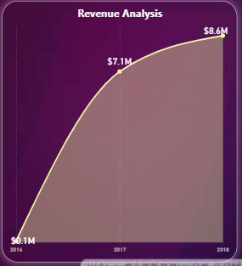

Key insights and findings

* The strong jump from 2016 to 2017 reflects effective scaling strategies—possibly new product launches, expanded markets, or increased customer acquisition.
* The slower growth rate in 2018 may indicate market saturation, rising competition, or the need for innovation to sustain momentum.
* Strategic actions such as diversifying products, enhancing marketing, or entering new markets could help maintain revenue growth.